Project report :

<https://github.com/mmwprime/image-filter-1222.git>

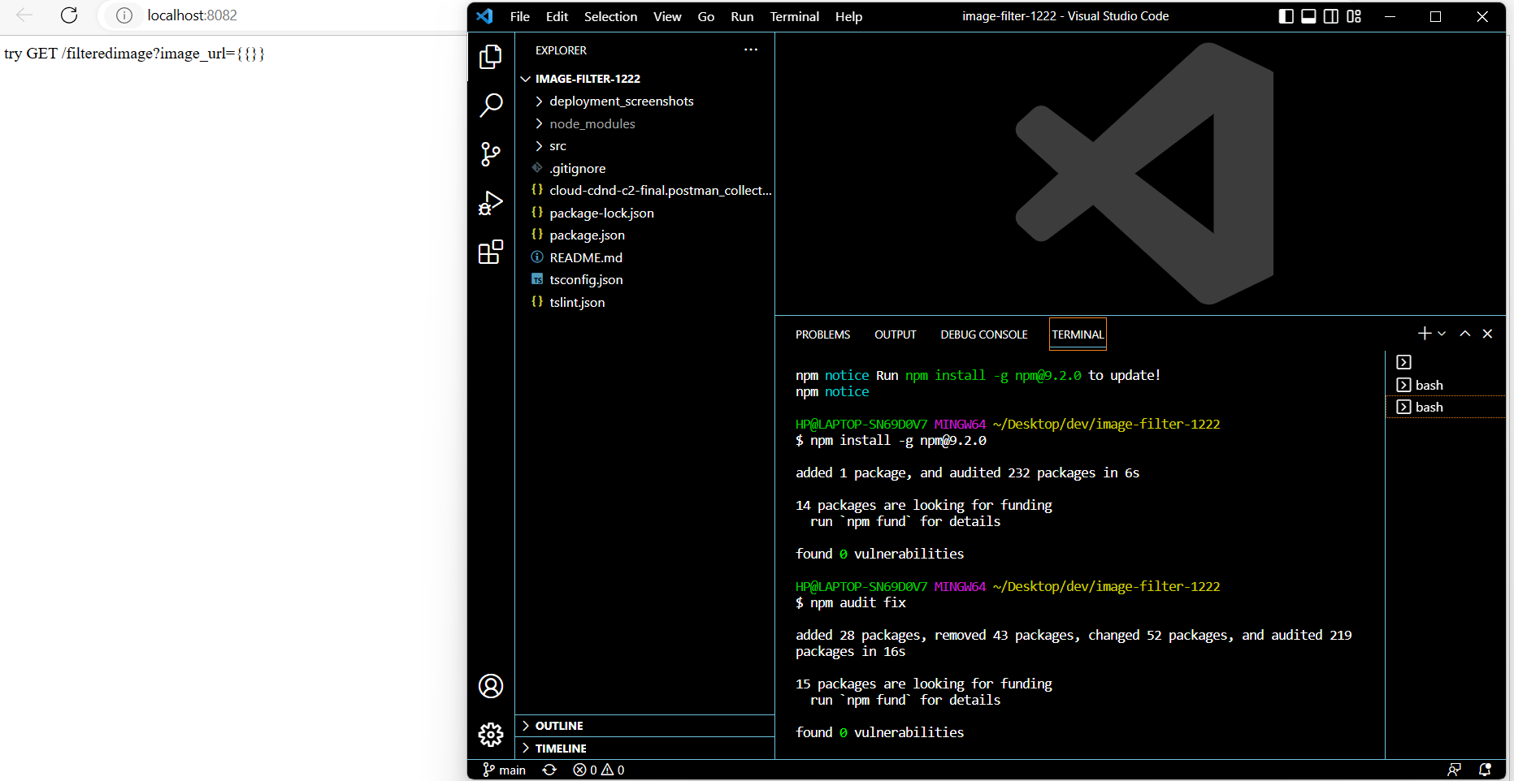

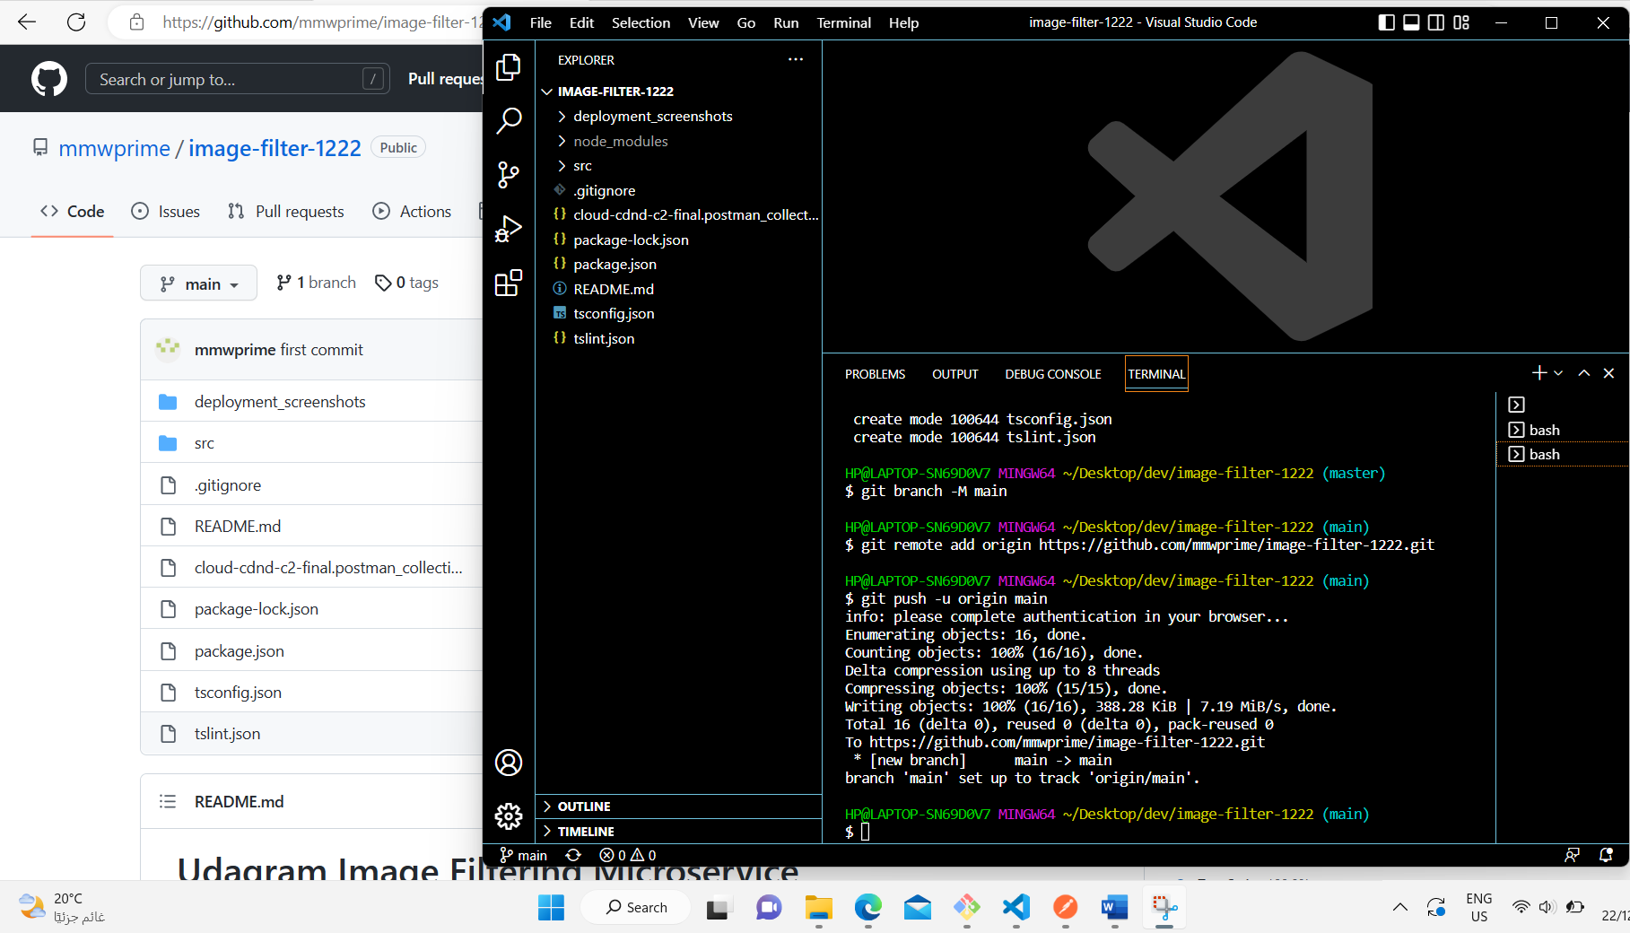

<http://localhost:8082/filteredimage?image_url=>

<https://mlrhpz8jmuut.i.optimole.com/cb:Ie5o.50122/w:auto/h:auto/q:mauto/https://www.egypttoursplus.com/wp-content/uploads/2018/04/Pharaonic-Village-Cairo.jpg>

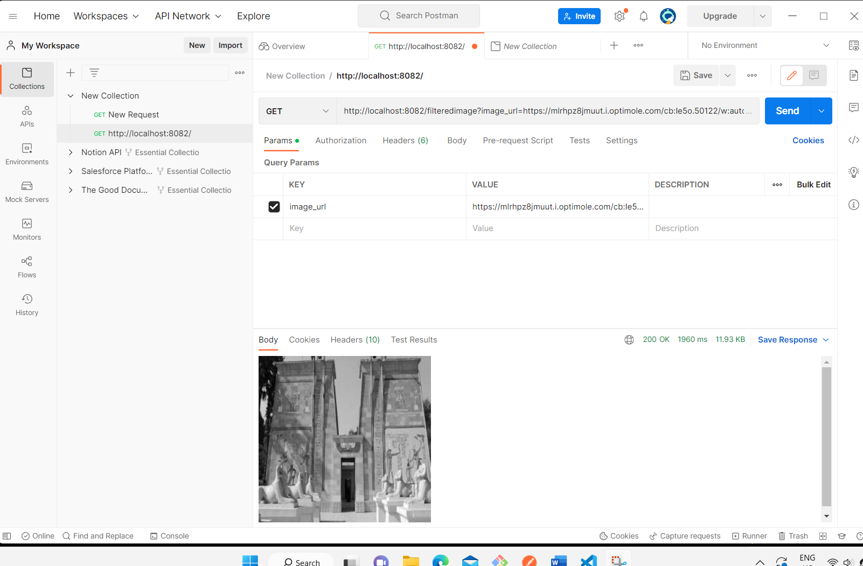

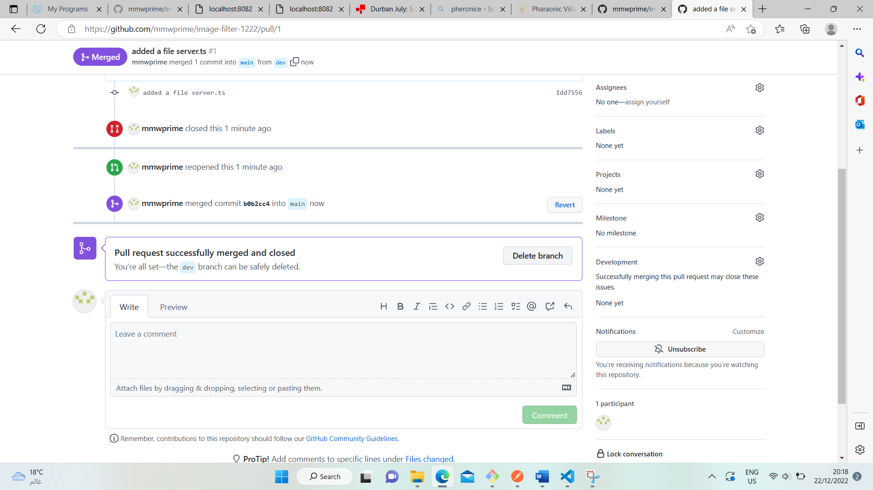

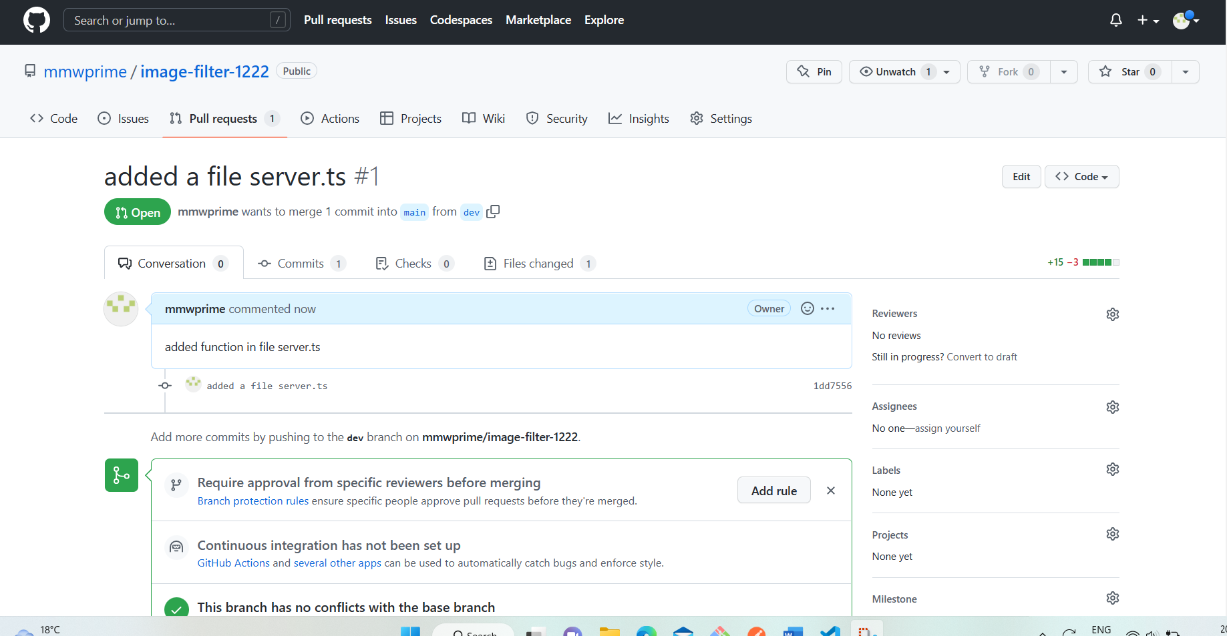

Typescript in package.json typescrip:”^4.0”

Npm update

Download zip ,Copy zip file to window\, windows \system32

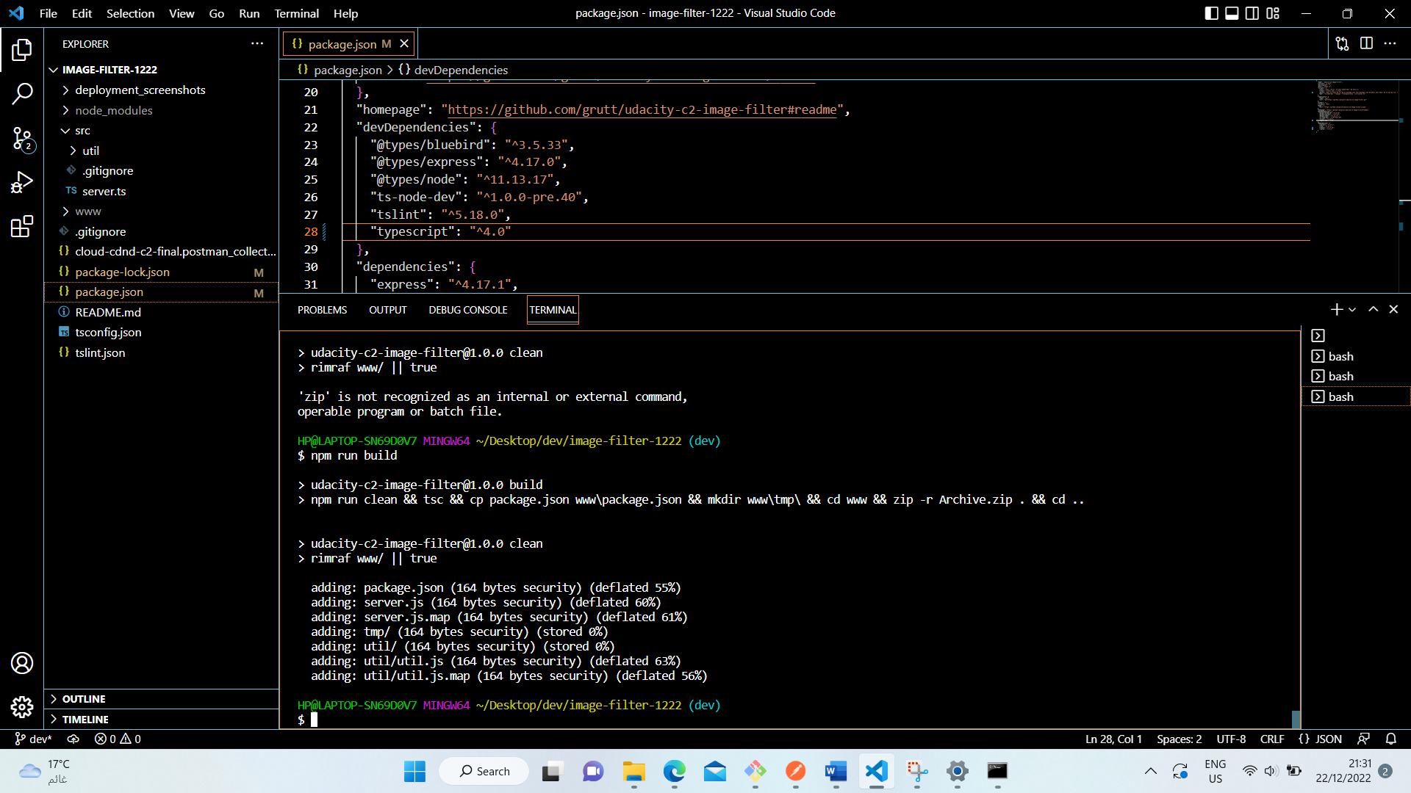

awsEbcli install

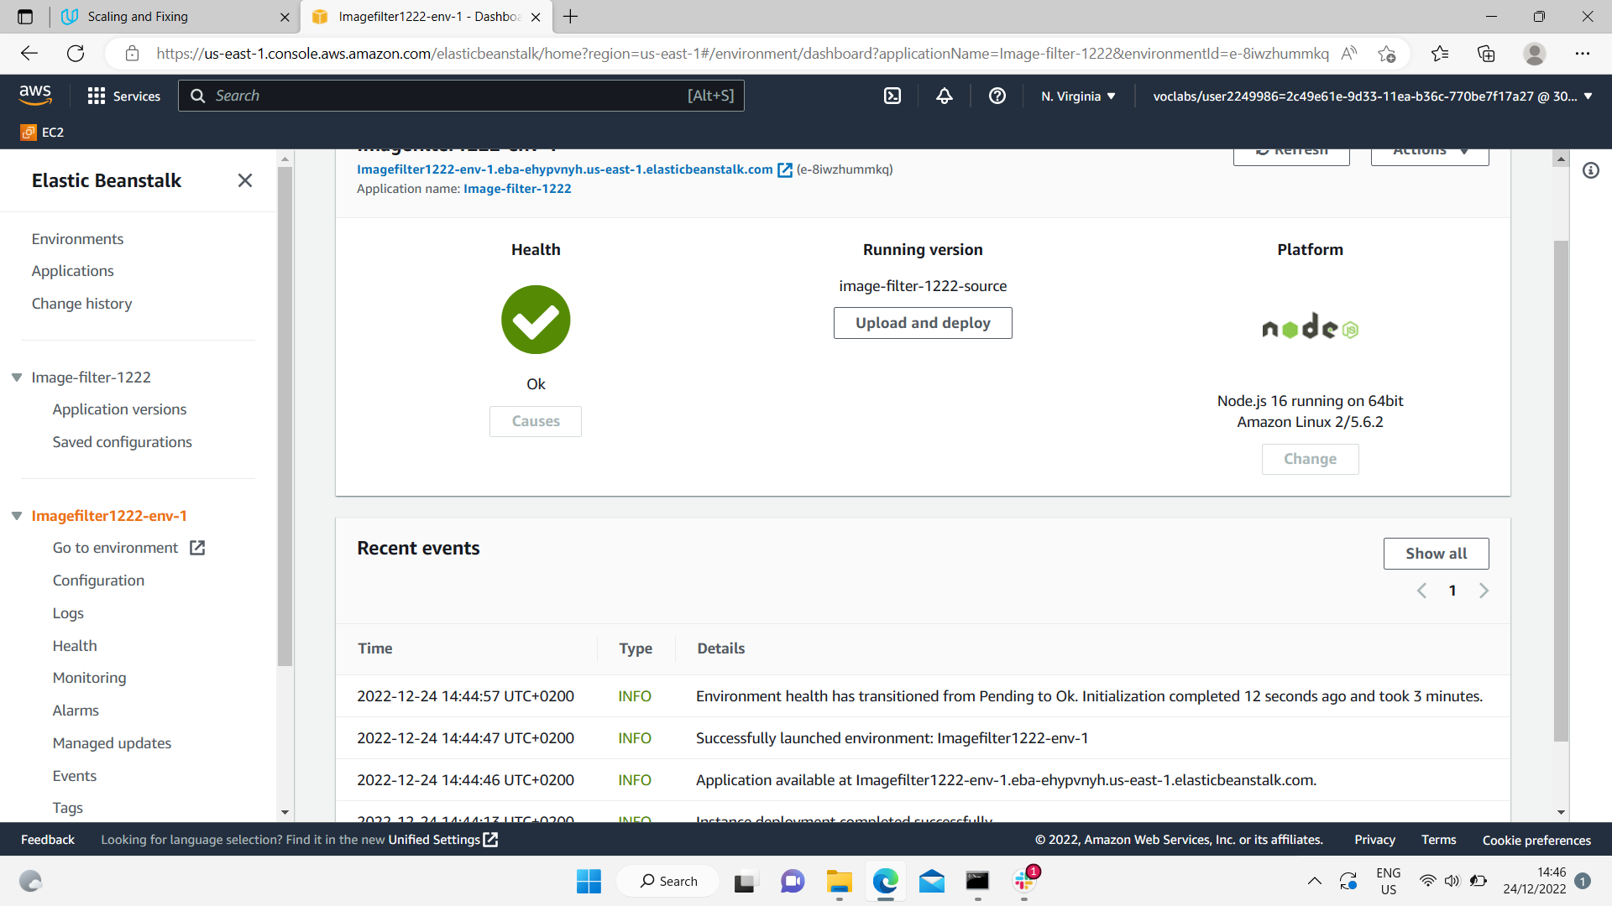

<http://imagefilter1222-env-1.eba-ehypvnyh.us-east-1.elasticbeanstalk.com/>

